**Lesson Notes**

1. What is the main purpose of an Operating System?

**Simpler / More efficient application programs**

**Consistent User Experience**

**All Multiple Applications Running at Same Time**

1. What is the difference between Operating System Software and Use Application Software?

**Applications focus on what is contained and displayed within a window**

**Operating System controls opening / closing / resizing windows and responding to mouse and keyboard actions**

**Operating System provides standard ways to print, save and open files, access the internet, etc.**

1. What is the difference between Operating System Software and Computer Hardware?

An **operating system is** a layer **of software** that provides a common set **of** services to manage the underlying **hardware**. ... An **operating system is** a layer **of software** that provides a common set **of** services to manage the underlying **hardware**. This helps to make application development easier.

1. What are the main parts of an Operating System?

* Graphical User Interface (GUI)
  + Manages Windows Display, mouse, keyboard, sound, etc. and provides feedback to user application programs through system calls.
  + System Calls
  + Allows user application programs to access Operating System resources
  + Allows Operating System to provide feedback to user programs
  + Device Drivers
  + Converts a basic function (e.g. Display a Pixel) to detailed commands for a specific make and model of hardware (e.g. Nvidia GeForce RTX 2070)
  + I/O Manager
  + Schedules access to input / output devices (e.g. disk drive) to avoid conflicts between user applications

1. What are some popular operating systems?

* Windows OS
  + PCs / Laptops / Tablets
  + Mac OS
  + PCs / Laptops
  + Linux / Unix
  + PCs / Laptops / Phones / Embedded Devices
  + Android / Chrome
  + Phones / Tablets / Embedded Devices
  + iOS
  + Phones / Tablets
  + z/OS
  + IBM Mainframe Computers

**Reference Diagram**

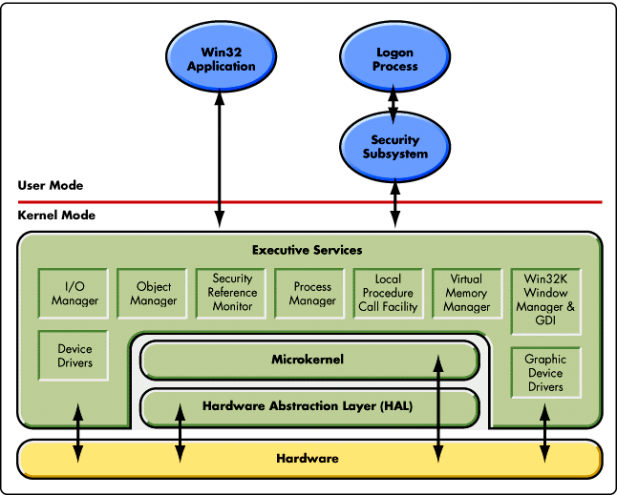

**Student Questions**

1. What is a device driver?
   1. Provide a brief summary
   2. A device driver is a file that lets the computer know the configuration and specifications of a certain hardware device.
   3. List some devices that require a device driver.

**DVD Drives.**

* 1. Provide a label on the reference diagram for the location of a device driver for your graphics card.

**On Chart**

* 1. Provide a label on the reference diagram for the location of a device driver for a locally attached printer.

**On Chart**

1. What is a DLL?
   1. Provide a brief summary

**DLL (Dynamic-link Library) is used for holding multiple codes and procedures for**

**Windows programs**

* 1. Explain how DLLs are related to user application programs

DLLs tend to be used to open applications, it is similar to .EXE files

* 1. Provide a label on the reference diagram for the location of a DLL

1. What is a windows manager?
   1. Provide a brief summary

**WM is a system software that controls the placement and appearance of windows within a windowing system in a graphical UI**

* 1. Explain how a windows manager is related to user application programs

**Windows Manager is related to user application programs in a way that is it used to: minimize, maximize, move, and close windows that run programs.**

1. What is the windows task manager?
   1. Provide a brief summary

**Task manager is used to show information about the programs and processes running on a computer. Task manager also shows the general status of the computer. The task manager can be used to terminate processes and programs as well as suspending them.**

* 1. List and explain four (4) types of system information provided by the task manager

**CPU temperatures, time running of computer, running processes and programs, and amount of memory being used for CPU, GPU, RAM.**

* 1. Provide a label on the reference diagram for the operating system components related to each type of information.

**On Chart**